[Insert Coalition Name]
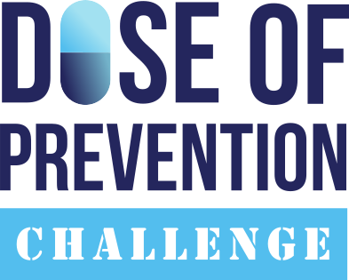
Holds Town Hall Meeting
to Discuss Community Solutions for Rx and OTC Misuse and Abuse
Event held during National Medicine Abuse Awareness Month

INSERT CITY/STATE (MONTH XX, 2025) – At one point or another, we’ve all used prescription drugs or over-the-counter (OTC) medicines to alleviate an illness – whether it’s to relieve pain or curb a cough. Unfortunately, too many young people and adults are abusing these drugs for a quick high.

In response to our country’s medicine abuse epidemic, the [insert coalition name] coalition is holding a town hall meeting to address this issue and receive community input on how to solve this problem at [time, date and location here.]

The event is part of our commitment to the Dose of Prevention Challenge, a national initiative aimed at empowering communities to take proactive steps in preventing prescription and OTC medicine abuse. The town hall will feature [names, titles, etc. of any speakers] who will cover the following information: [event specific information for your town hall and/or educational event here]

Nationally, prescription drugs are the second most abused category of drugs after marijuana, with one in three young adults reporting that they have abused a prescription drug. In addition, the 2020 National Institute on Drug Abuse and University of Michigan’s Monitoring the Future survey found that 3.7 percent of teens have abused OTC cough medicines containing the active ingredient dextromethorphan to get high, an increase from 2.8 percent in 2019 . When abused in extreme excess—sometimes as much as 25 to 50 times the recommended dose— dextromethorphan can produce dangerous side effects, especially when combined with alcohol, illicit drugs, or certain prescription drugs.

Locally, the statistics are staggering: [insert any local or state-wide data pertaining to Rx and/or OTC abuse here]

“Our coalition has been working tirelessly to reduce and prevent medicine abuse by teens and adults since [year] through education, community engagement, and local policy changes,” said [coalition representative and title]. “By bringing together parents, educators, health professionals and other concerned citizens for this community forum, we hope we can prevent further tragedies involving prescription drugs or over-the-counter medicines.“

The event coincides with National Medicine Abuse Awareness Month, observed annually in October. The [name of coalition] is one of hundreds across the country holding similar events. The national campaign, sponsored by CADCA and the Consumer Healthcare Products Association, aims to educate parents and youth of the potential dangers associated with prescription and OTC medicine abuse.

If you’re interested in attending this event, contact [insert coalition contact name, phone and e-mail address].

[Insert Description of your coalition or your mission statement here.]

# # #

