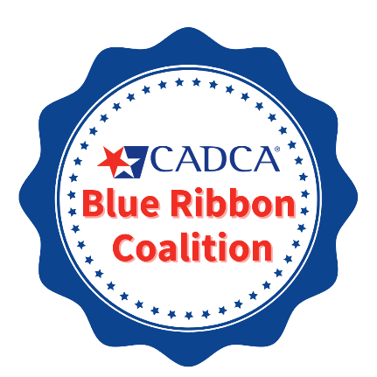

2023 Blue Ribbon Application
(Formerly Got Outcomes! Awards)
Phase I Application Announcement

Deadline: June 30, 2023

Thank you for your interest in CADCA’s 2023 Blue Ribbon Application process! This is your coalition’s opportunity to receive national recognition for positive community-level outcomes achieved. The application process draws on the actual products used by coalitions and offers coalitions the ability to strengthen these existing products to make an effective case for its contributions to community-level outcomes.

This is the first phase of a two-phase process. In Phase I, CADCA will review and score each of the coalition’s products (e.g., Community Assessment, Logic Model…). Coalitions meeting a threshold score will advance to Phase II. Advancing finalists will be recognized as **Blue Ribbon Coalitions** and invited to tell their coalition’s story of how they have contributed to changes in their community-level outcomes. The highest scoring Phase II applicants will receive the prestigious Blue Ribbon Awards in the following categories:

Coalition in Focus: Short-term Outcomes
Coalition of Excellence: Intermediate Outcomes
Coalition of the Year: Long-term Outcomes

**Blue Ribbon Coalition is a two-year recognition. Once two years have passed, coalitions can re-earn their recognition status through the Blue Ribbon Application process. Coalitions who re-apply before the two years are expired and achieve Blue Ribbon Coalition will have their two-year status restarted.

Become a CADCA Blue Ribbon Coalition!
The CADCA Blue Ribbon Coalitions are able to take what they’ve learned at the National Coalition Academy and apply it to their coalition’s work. They are recognized for doing an exceptional job updating and utilizing their coalition products in order to set themselves up for community success. In addition, they have been recognized by members of the U.S. House of Representatives and by the Director of the Office of National Drug Control Policy.

Becoming a Blue Ribbon Coalition can become a platform to obtain local and national recognition, used in other grant applications, and to pursue other funding agreements. A great demonstration of using the Blue Ribbon Coalition name is Beech Grove Comprehensive Drug Free Coalition. They brought in the Mayor of Beech Grove and General Price from CADCA to celebrate the Blue Ribbon Coalition recognition and showcase the community partners involved in their coalition’s success!

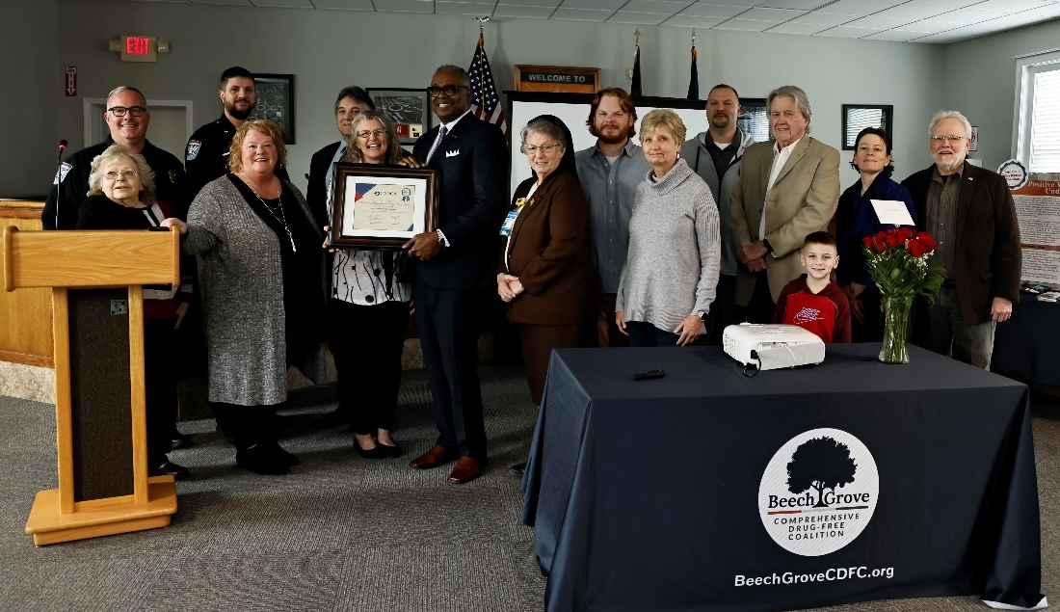

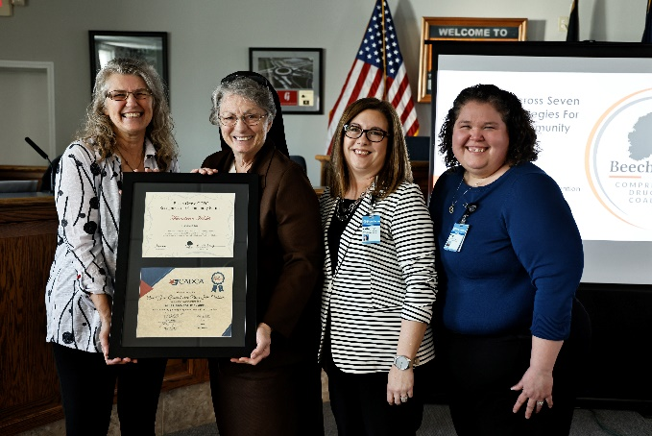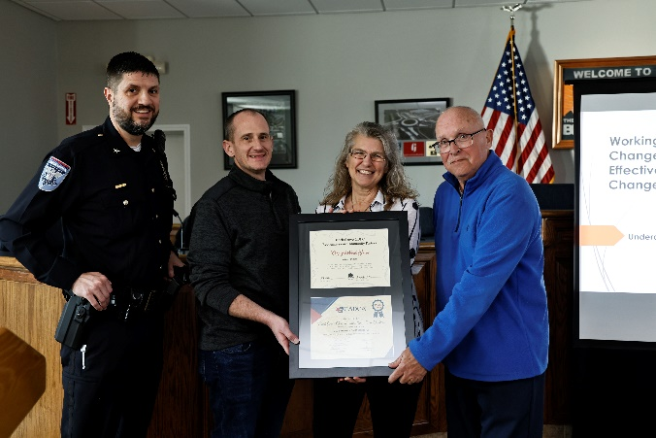

Benefits to Applicants
Benefits for ALL applicants
- In depth feedback provided for each of your coalition’s products.
- Free coalition development support to discuss enhancements to products.

Benefits for Phase II Finalists
- In depth feedback provided for each of your coalition’s products.
- Free coalition development support to discuss enhancements to products.
- 2-year recognition as a CADCA Blue Ribbon Coalition.
- Recognition in CADCA’s Coalitions Online Weekly Newsletter, on CADCA’s Blue Ribbon Application website, and other CADCA communications.
- Opportunity to attend CADCA’s Blue Ribbon Awards during CADCA’s 2024 Annual National Leadership Forum in National Harbor, MD on January 29-February 1, 2024.
- Opportunity to participate in the Ideas Fair Poster Presentation at the 2024 National Leadership Forum.
- Eligibility to participate in the Graduate Coalition Academy (GCA).

Benefits for Blue Ribbon Award Winners
- In depth feedback provided for each of your coalition’s products.
- Free coalition development support to discuss enhancements to products.
- 2-year recognition as a CADCA Blue Ribbon Coalition.
- Recognition in CADCA’s Coalitions Online Weekly Newsletter, on CADCA’s Blue Ribbon Application website, and other CADCA communications.
- Free lodging, travel, and registration for one coalition member to attend CADCA’s 2024 Annual National Leadership Forum in National Harbor, MD on January 29-February 1, 2024.
- A custom award with your coalition’s name and successes engraved on the front.
- Recognition in CADCA’s Annual Printed Coalitions newsletter, on CADCA’s Blue Ribbon Application website, and other CADCA communications.
- Coalition featured at the CADCA Blue Ribbon Application Workshop at the 2024 National Leadership Forum.
- Coalition leaders to be considered for CADCA training/leadership opportunities (e.g., CADCA Advisory boards).

Eligibility Requirements
The Blue Ribbon Application process focuses on making the link between your coalition’s community assessment data, logic model, comprehensive strategies and the resulting community-level outcomes. To apply, your coalition must have achieved, at a minimum, positive short-term outcomes (positive results related to changes in local conditions) associated with one substance misuse issue. When applying you can designate which level of award for which your coalition seeks to apply according to the categories listed below.

- Coalition in Focus Award: Short-term outcomes (changes to local conditions)
- Coalition of Excellence Award: Short-term and Intermediate outcomes (changes to root causes)
- Coalition of the Year Award: Short-term, Intermediate, and Long-term outcomes (changes to problem statements)

Join Our Upcoming Phase I Informational Webinar
CADCA will walk you through the application and discuss tips for strengthening your coalition’s case for contribution to community-level outcomes. The informational webinar will take place on Tuesday, April 18, 2023 at 1pm ET. Click on this link to complete the required pre-registration.

2023 Blue Ribbon Application Timeline (subject to change)
CADCA Announces Blue Ribbon Application Process | Apr. 4, 2023
Phase I Application assistance and feedback by CADCA’s Coalition Development Support (CDS) team | Apr. 5 – Jun. 29, 2023
Phase I applicant informational webinar  (must pre-register before webinar date) | Apr. 18, 2023
Phase I applications due to CADCA | Jun. 30, 2023
Phase I applications reviewed by CADCA trainers | Jul. 3 – Aug. 18, 2023
CADCA notifies finalists and announce Blue Ribbon Coalitions | Week of Aug. 21, 2023
Phase II application assistance and feedback by CADCA’s Coalition Development Support (CDS) team | Aug. 21 – Sept. 22, 2023
Phase II applications due to CADCA | Sept. 22, 2023
Phase II applications reviewed by CADCA Trainers | Sept. 25 – Oct. 27, 2023
Phase II winners notified! | Week of Oct. 30, 2023
Winners contacted regarding 2024 National Leadership Forum | Week of Oct. 30, 2023
Blue Ribbon Coalitions Awards and present at the 2024 National Leadership Forum Ideas Fair | Jan. 29 – Feb. 1, 2024
Phase II winners present a session at the 2024 National Leadership Forum | Jan. 29 – Feb. 1, 2024
Phase II winners celebrated at National Leadership Forum Awards Luncheon | Feb. 1, 2024

Application Required Materials
Materials required to apply for CADCA’s 2023 Blue Ribbon Application include coalition products relating to ONE substance, including:

- Community Assessment (maximum 15 pages) (i.e., can include full assessment with more than one substance)
- Substance specific Logic Model (including all elements: one problem, two root causes, four local conditions with at least two data measures mapped to each)
- Strategic and Action Plan (e.g., including objectives, strategies, and action plans as outlined in the requirement for each award category [i.e., Short-term outcomes; Short-term and Intermediate outcomes; Short-term, Intermediate, and Long-term Outcomes])
  - Vision
  - Mission
  - Objectives and strategies for Increasing community collaboration (i.e., Goal 1 for DFC Grant Recipients) including those that led to the outcomes being highlighted
  - Objectives and strategies for Reducing substance use/misuse (i.e., Goal 2 for DFC Grant Recipients) including only those that led to the outcomes being highlighted
  - Strategies and Action Plan
- Evaluation Plan (at least two data measures for the problem, one root cause and one local condition)
- Evaluation Communication Plan (i.e., minimum of three audiences as it relates to the local conditions on the logic model)
- Sustainability Plan (i.e., must showcase the outcomes you are presenting)
- Description of Coalition Outcomes (maximum 3 pages) (short-term, intermediate, and/or long-term)

*See Appendix A for application materials templates. See Appendix B for Grading Rubric.

Application Steps

- STEP 1: Select ONE youth substance use issue that your coalition has successfully addressed and would like to highlight in this application. While your coalition may have achieved success addressing more than one substance use issue, you will need to come to a consensus about which one to highlight.

- STEP 2: Identify the community-level outcomes your coalition has contributed to in the substance use issue identified in Step 1. Will you be highlighting the achievement of Short-term outcomes? Short-term and Intermediate outcomes? Short-term, Intermediate, and Long-term outcomes?

  - *Coalition in Focus (short-term outcomes): The submitted outcomes must tie to your logic model, specifically for:
    - One local condition
  - *Coalition of Excellence (short-term and intermediate outcomes): The submitted outcomes must tie to your logic model, specifically for:
    - Two local conditions for one root cause OR
    - One local condition for two root causes
  - *Coalition of the Year (short-term, intermediate, and long-term outcomes): The submitted outcomes must tie to your logic model, specifically for:
    - Two local conditions for one root cause and problem OR
    - One local condition for two root causes and problem.
*See Appendix B for examples of outcomes connected to logic model

- STEP 3: Submit the required coalition products for the substance your coalition has selected. Applications with missing required content will be disqualified. No additional materials will be reviewed.

- STEP 4: Submit a description of Coalition Outcomes (short, intermediate and/or long-term). The outcomes should include the baseline and follow up data measures. The total number of follow up data measures will vary on the category you are applying for in the application.

  - Coalition in Focus
    - Short-term 6-24 months (baseline and 1-2 follow up data points)
  - Coalition of Excellence
    - Above requirements + Intermediate 1-4 years (baseline and 2-3 follow up data points)
  - Coalition of the Year
    - Above requirements + Long Term 3-10 years (baseline and 3-4 follow up data points)

Submitting Your Phase I Application
Your Phase I application must be submitted to CADCA no later than Friday, June 30, 2023 by 11:59pm (EST). Please submit your application materials as ONE FILE (accepted formats are .pdf, .doc, and .docx) through our online Blue Ribbon Application Submission. If you have any questions about the submission process or have trouble submitting, email blueribbon@cadca.org.

The following required documents should be saved as ONE FILE (accepted formats: .pdf, .doc, .docx)

- Community Assessment
- Logic Model
- Strategic and Action Plan
- Evaluation Plan
- Evaluation Communication Plan
- Sustainability Plan
- Description of Coalition Outcomes (short-term, intermediate, and/or long-term)

Support for Phase I Applicants: If you have any questions about application requirements, please contact Katrina Yi, Evaluation & Research Evaluator, before 3 pm EST on Friday, June 30, 2023 at 1-800-54-CADCA, ext. 267 or blueribbon@cadca.org.

If you would like additional support and feedback on your application products, please reach out to the Coalition Development Support team at training@cadca.org or book an appointment with them and mention “Blue Ribbon Application”.

Appendix A: Coalition Product Templates

Community Assessment Template

Coalition:
Community Description
- Definition of the Community (e.g., county, city, multiple counties, cities, zip codes)
- Geographical characteristics of the community
- Population Demographics (e.g., total population. age distribution, race/ethnicity, gender)
- Jurisdictions (e.g., law enforcement agencies, school districts, cities/towns, health departments)
- Communities within the Community including different cultures and diverse populations that exist in your community.
Community History
- Key events have specifically affected the community.
- History of substance use related issues in the community.
- History of community organization efforts /coalition building.
- Health Disparities that have been identified in the community.
- Description of how this history impacts the coalition’s ability to work in the community.
Needs Assessment
  - Data Collection Methods: Describe the different tools and methods used to collection needs assessment data for your community.
  - For each drug identify:
    - Consequences
    - Problem behaviors (drug use)
    - Root causes, local conditions and health disparities
Community Resources
- Describe the resources that can be used to change local conditions including:
- Prevention resources: facilities, programs, organizations and initiatives
- Protective factors / assets that promote a healthy environment and decisions
- Prevention Infrastructure: systems, data sources, laws and policies, funding
- Identify any gaps or disparities in resources.
Problem / Goal Statements
- Write one Problem / Goal Statement for each drug to be addressed.
- Describe why each drug was prioritized.

Coalition Logic Model Template
*Full Logic Model with problem, two root causes, and four local conditions with at least two data measures mapped to each must be submitted for the Blue Ribbon Application.

Problem Root Causes Local Conditions & Data (Specific, identifiable, actionable)
Measure, Data, Source & Date #1:

Measure, Data, Source & Date #2:

Measure, Data, Source & Date #1
Measure, Data, Source & Date #1:

Measure, Data, Source & Date #2:

Measure, Data, Source & Date #1:

Measure, Data, Source & Date #2:

Measure, Data, Source & Date #1:

Measure, Data, Source & Date #2:

Measure, Data, Source & Date #1:

Measure, Data, Source & Date #2:

Measure, Data, Source & Date #1:

Measure, Data, Source & Date #2:

Strategic and Action Plan Template

Coalition:
Vision:
Mission:

Goal #1: Increase Community Collaboration: Establish and strengthen collaboration among communities, public and private non‐profit agencies, as well as federal, state, local, and tribal governments to support the efforts of community coalitions working to prevent and reduce substance use and misuse among youth

Directions: The following are categories that your coalition should consider when planning for goal #1. In each year, you may not complete activities for each category, but they should provide a framework for how your coalition can increase and build community collaboration. Must provide at least 3 of the community collaboration categories below.

Category: Outreach and Networking
Objective: insert SMART objective
Strategy 1: Briefly describe Outreach and Networking strategy. If incorporating multiple strategies, add strategy 2, 3, etc. followed by chart.
Activity | Who is responsible | By When?

Category: Public Awareness of Substance Use and Misuse Issues
Objective: insert SMART objective
Strategy 1: Briefly describe Public Awareness of Substance Use and Misuse Issues strategy. If incorporating multiple strategies, add strategy 2, 3, etc. followed by below chart.
Activity | Who is responsible | By When?

Category: Coalition Communications and Branding
Objective: insert SMART objective
Strategy 1: Briefly describe Coalition Communications and Branding strategy. If incorporating multiple strategies, add strategy 2, 3, etc. followed by below chart.
Activity | Who is responsible | By When?

Category: Community Education and Training
Objective: insert SMART objective
Strategy 1: Briefly describe Community Education and Training strategy. If incorporating multiple strategies, add strategy 2, 3, etc. followed by below chart.
Activity | Who is responsible | By When?

Category: General Prevention Activities
Objective: insert SMART objective
Strategy 1: Briefly describe General Prevention Activities strategy. If incorporating multiple strategies, add strategy 2, 3, etc. followed by below chart.
Activity | Who is responsible | By When?

Category: Build Coalition Capacity to Collaborate
Objective: insert SMART objective
Strategy 1: Briefly describe Build Coalition Capacity to Collaborate strategy. If incorporating multiple strategies, add strategy 2, 3, etc. followed by below chart.
Activity | Who is responsible | By When?

Goal #2: Reduce youth substance use and misuse: Reduce substance use and misuse among youth and, over time, reduce substance use and misuse among adults by addressing the factors in a community that increase the risk of substance use and misuse and promoting the factors that minimize the risk of substance use and misuse.

Directions: The following should demonstrate the strategies that your coalition is implementing in the given year (e.g., year 2, 4, 5) and the activities associated with implementing each strategy. Must include all 7 strategies. Repeat for each local condition being highlighted in the application.

Problem (substance): insert
- Long-term objective (3-10 years): insert based on the data provided on logic model

Root Cause: insert
- Intermediate objective (1-4 years): insert based on the data provided on logic model

Local Condition: insert
- Short term objective (6-24 months): insert based on the data provided on logic model

*Strategies should directly connect back to the local condition.

Strategy 1: Provide Information: insert Provide Information strategy
Activity | Who is responsible | By When?

Strategy 2: Build Skills: insert Build Skills strategy
Activity | Who is responsible | By When?

Strategy 3: Provide Support: insert Provide Support strategy
Activity | Who is responsible | By When?

Strategy 4: Enhance Access/Reduce Barriers: insert Enhance Access/Reduce Barriers strategy
Activity | Who is responsible | By When?

Strategy 5: Change Consequences (incentives/disincentives): insert Change Consequences strategy
Activity | Who is responsible | By When?

Strategy 6: Physical Design: insert Physical Design strategy
Activity | Who is responsible | By When?

Strategy 7: Modify/Change Policies: insert Modify/Change Policies strategy
Activity | Who is responsible | By When?

Evaluation Plan Template

Coalition Name __________________________________________________________________________

Logic Model | Measure |  | Baseline  Data / Date | Data  Source | Collection Frequency
Local Conditions
Sensitive
Proximate
Feasible
Sensitive
Proximate
Feasible
Sensitive
Proximate
Feasible
Sensitive
Proximate
Feasible
Sensitive
Proximate
Feasible
Sensitive
Proximate
Feasible
Sensitive
Proximate
Feasible
Sensitive
Proximate
Feasible
Root Causes
Sensitive
Proximate
Feasible
Sensitive
Proximate
Feasible
Sensitive
Proximate
Feasible
Sensitive
Proximate
Feasible
Problem Statement
Sensitive
Proximate
Feasible
Sensitive
Proximate
Feasible
*Sensitive: Reflect community changes; Proximate: at the community level; Feasible: can be collected multiple times
Evaluation “Communication” Plan Template

*Must include at least 3 audiences

Coalition Name:
Who Cares About Substance use and misuse? | What do we want them to do? | How will they benefit from the coalition’s work”? | What data must be shared with the Audience? | How will the data be shared with the audience?
AUDIENCE | ACTION | WIFM | IINFORMATION | REPORT

Sustainability Plan Template

Case Statement:

Existing Resources/Termination Dates:

What needs to be sustained?

What future resources are required?

Key Strategies and Sources to Meet the Areas of Need (at least 4 funding strategies):
Strategies | Potential Sources - Actions

Action Plan to Implement Strategies:
Task | By Who? | By When? | Resources Required | Who needs to know?

Contact Information:

Coalition Outcomes Template
(max 3 pages)

1. Identify which Award Category your coalition is applying for (check 1):

- Coalition in Focus
  - Short-term 6-24 months (baseline and 1-2 follow up data points)

- Coalition of Excellence
  - Short-term 6-24 months (baseline and 1-2 follow up data points)
  - Intermediate 1-4 years (baseline and 2-3 follow up data points)

- Coalition of the Year
  - Short-term 6-24 months (baseline and 1-2 follow up data points)
  - Intermediate 1-4 years (baseline and 2-3 follow up data points)
  - Long Term 3-10 years (baseline and 3-4 follow up data points)

2. For the Award Category selected: (1) insert a table or graph of the baseline data and follow up trend data points and (2) include descriptive statement(s) about the data and outcomes achieved:

- Short-term 6-24 months (Must include baseline and 1-2 follow up data points)
Description:

- Intermediate 1-4 years (Must include baseline and 2-3 follow up data points)
Description:

- Long Term 3-10 years (Must include baseline and 3-4 follow up data points)
Description:

Appendix B: Download PDF Resources

Phase I Grading Rubric
Linking Outcomes to Logic Model by Award Category

